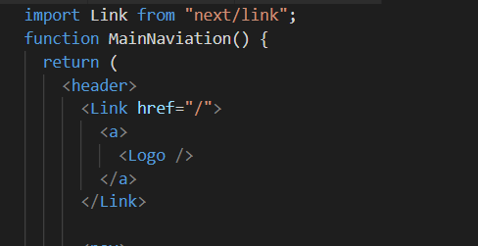

Importing CSS. If we do as below, class names will be allocated by next.js and will have some hash text.

1. Css file name : <something>.module.css
2. Import it as “classes”
3. When assigning className, give it as {classes.classname}

If anything other than text is passed inside the <Link> component, it should be wrapped inside <a>. This is give flexibility so that we can even make <p> tag clickable. For text it’s not necessary.

